**EXPERIMENT 11**

**Create a simple cloud software application for the online supermarket using any Cloud Service Provider to demonstrate SaaS with the template of customer name, address, phone, email, items, quantity, etc. with the item classification form,**

**Step 1: Create a Customer form for online supermarket**

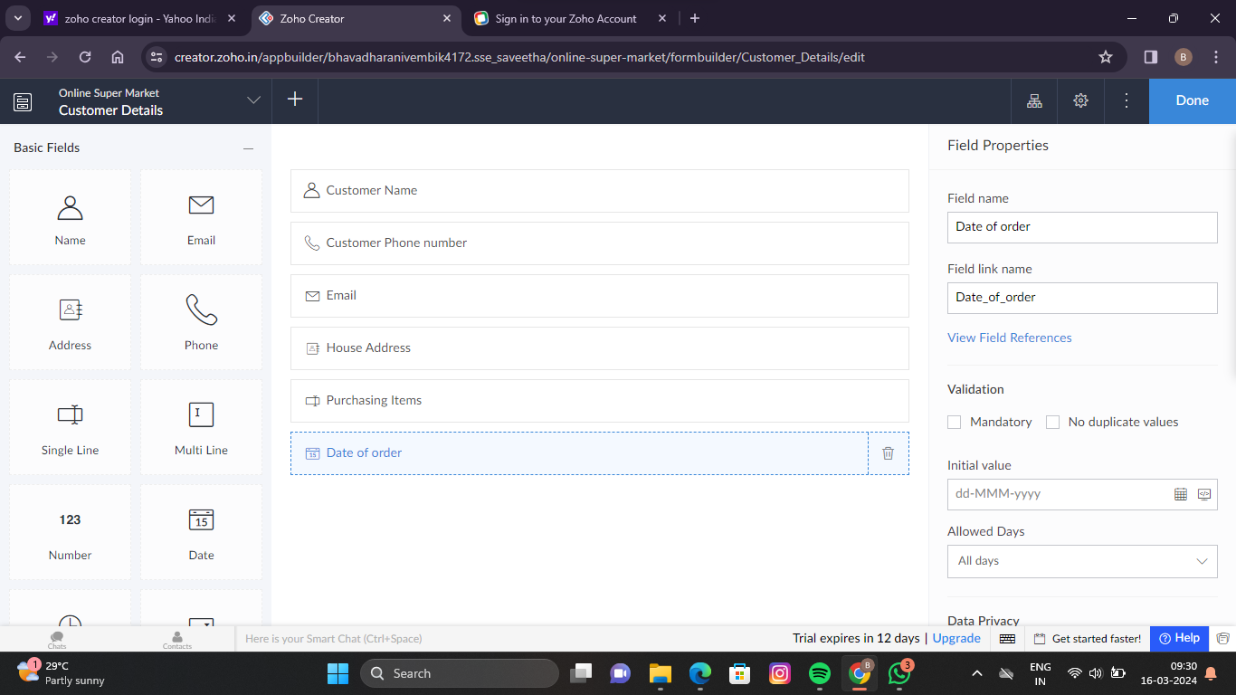

**Step 2: Create a delivery man detail form for online supermarket**

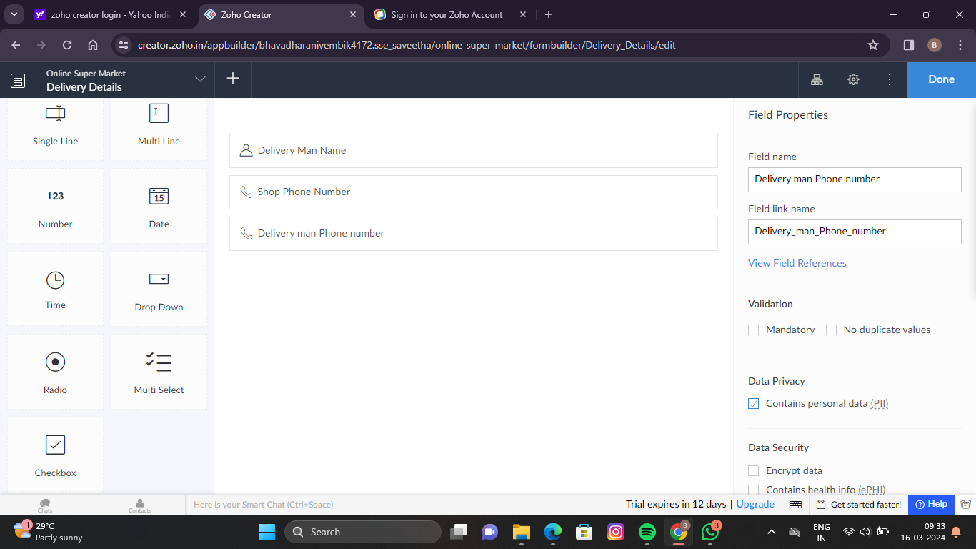

**Step 3: Create a purchasing Items form for the online supermarket**

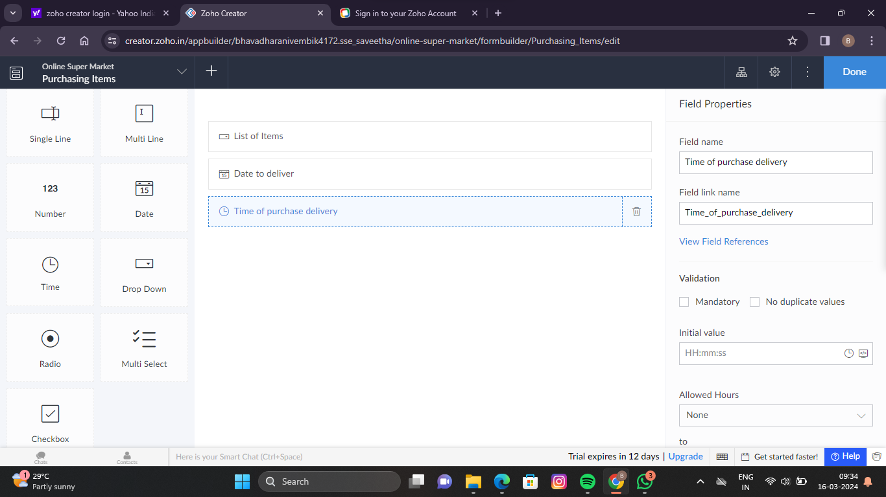

**Step 4: Enter customer details for the online supermarket**

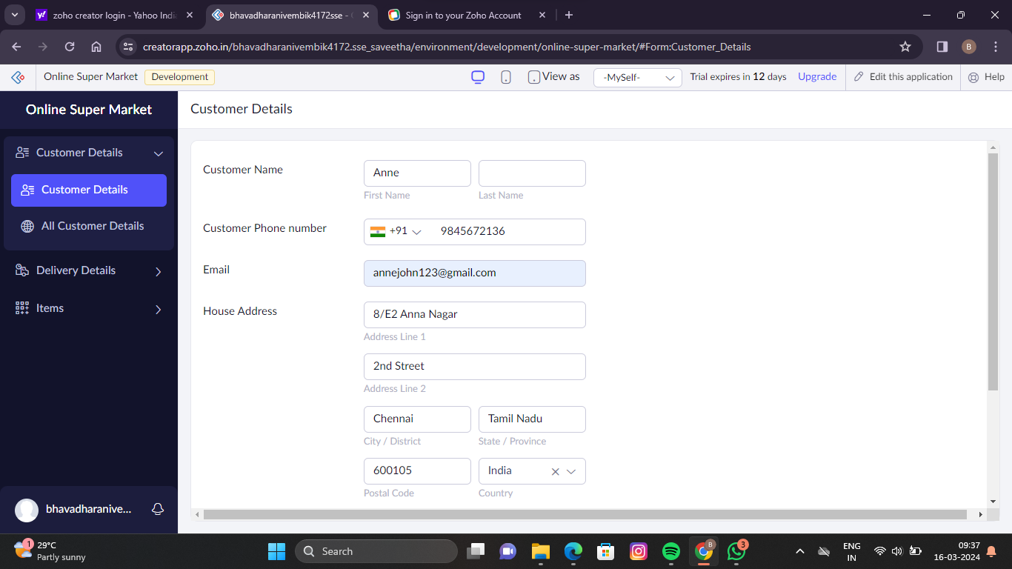

**Step 5: Enter the delivery man details for the online supermarket**

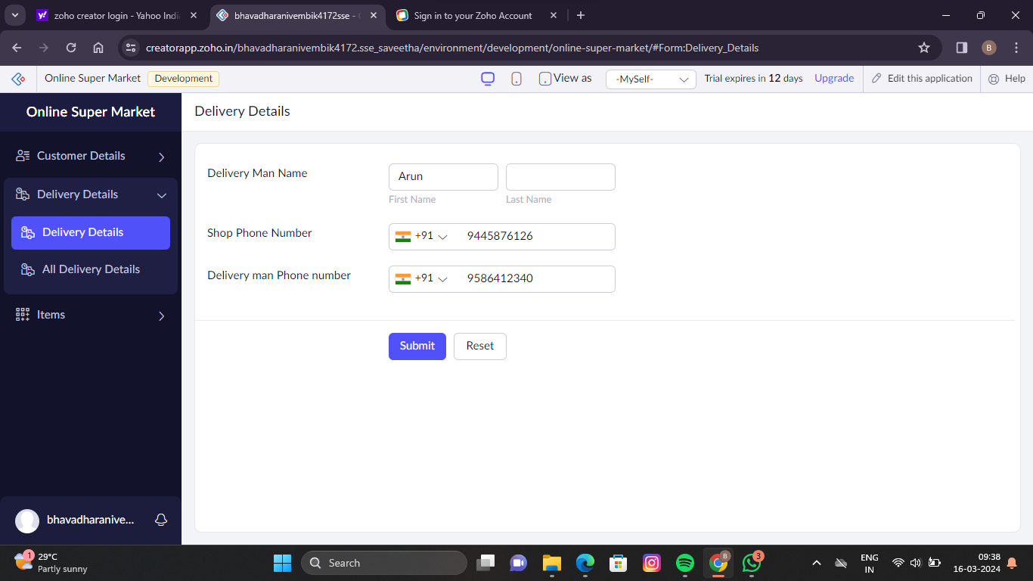

**Step 6: Enter the purchasing item details for the online supermarket**

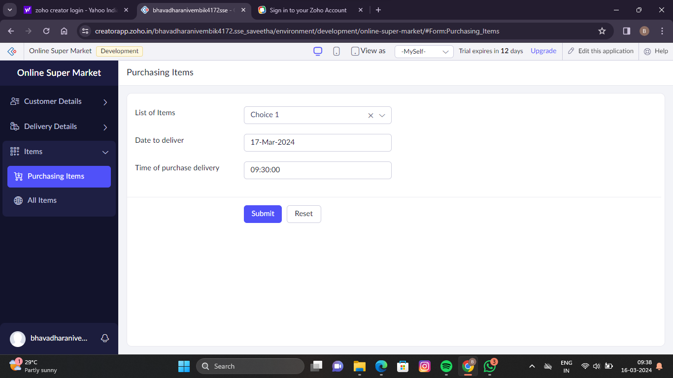

**Step 7: Display all the customer details for the online supermarket**

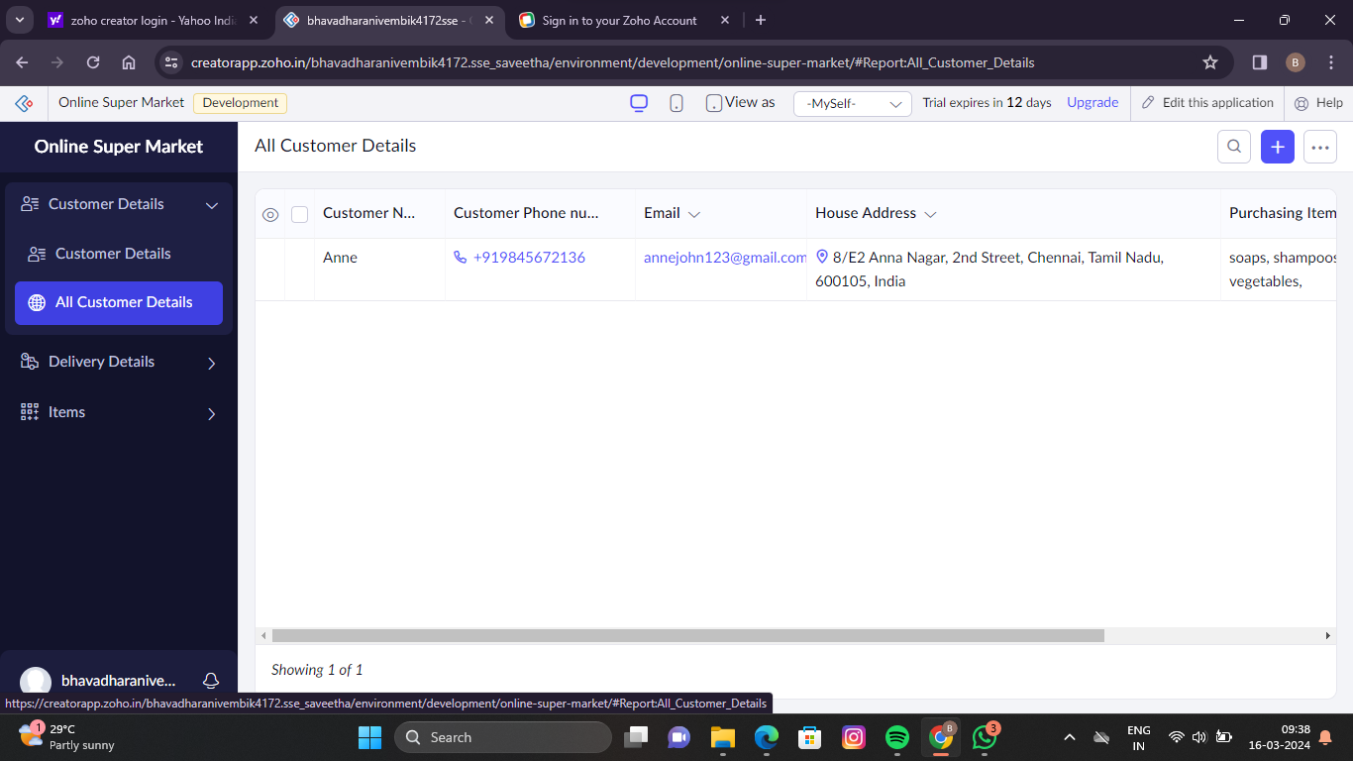

**Step 8: Display all the delivery details for the online supermarket**

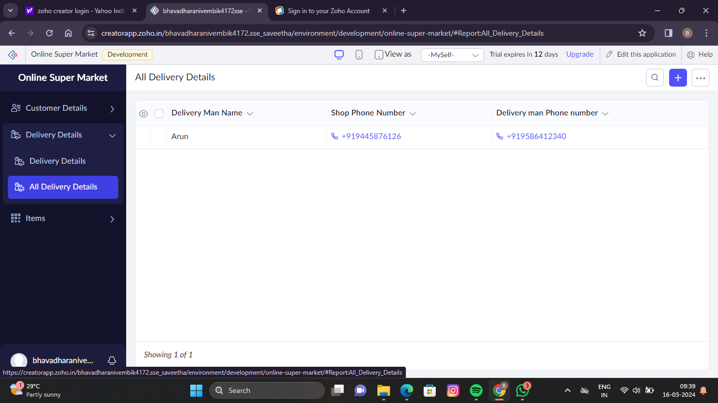

**Step 9: Display all the purchased items for the online supermarket**

